Practical Skill 2: Debugging with Console and Browser Developer Tools

Using console.log() Effectively
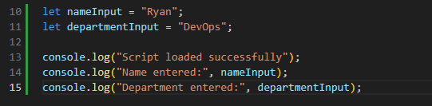

Console.warn() and console.error()
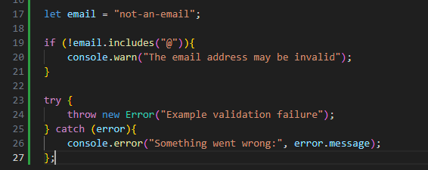
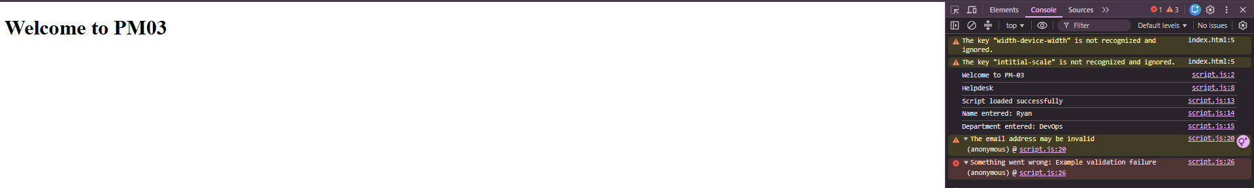

Practical Skill 4: DOM Manipulation

Reading input values

Needed to update the HTML to include entries in order for the JavaScript to be able to read them to the respected values.
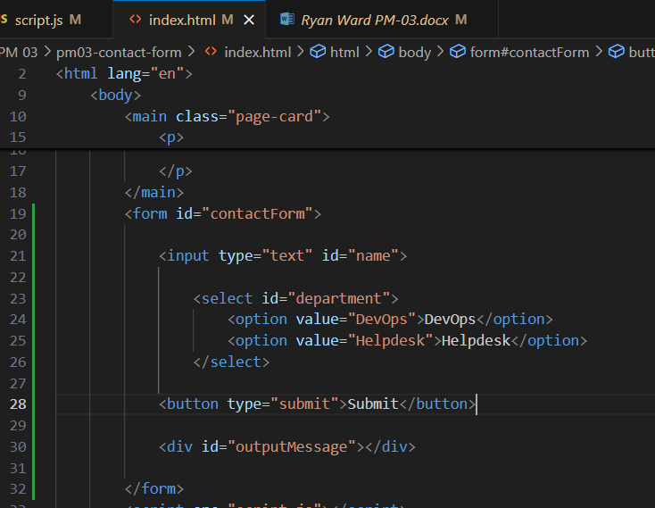

Adding Elements Dynamically

Needed to add an unordered list to the HTML so it can read the new list item
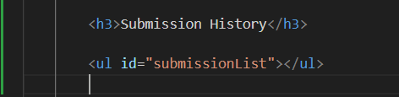

Removing Elements Dynamically

Needed to add a second button that links to the function to clear the status. Also need to amend the original script to the following in order for the button to work.
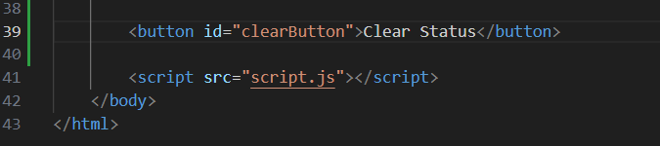
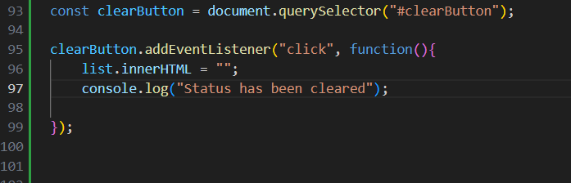

Practical Skill 5: Events

Input Event Example: Character Counter

Needed to add the following to the HTML page in order for the function to work.
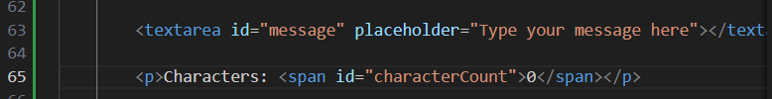

Practical Skill 6: Form Validation

Show message function:

In order for the results in the activity to show, HTML and JS needed to be amended.
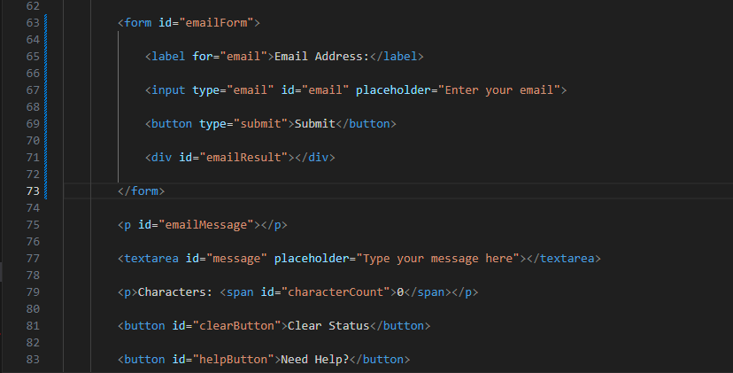
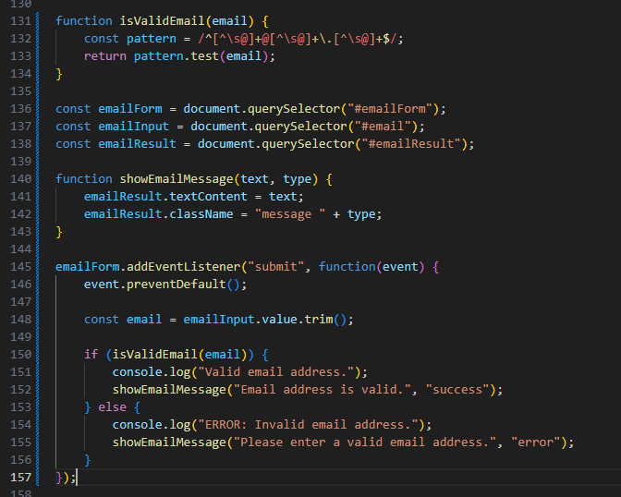
Before:
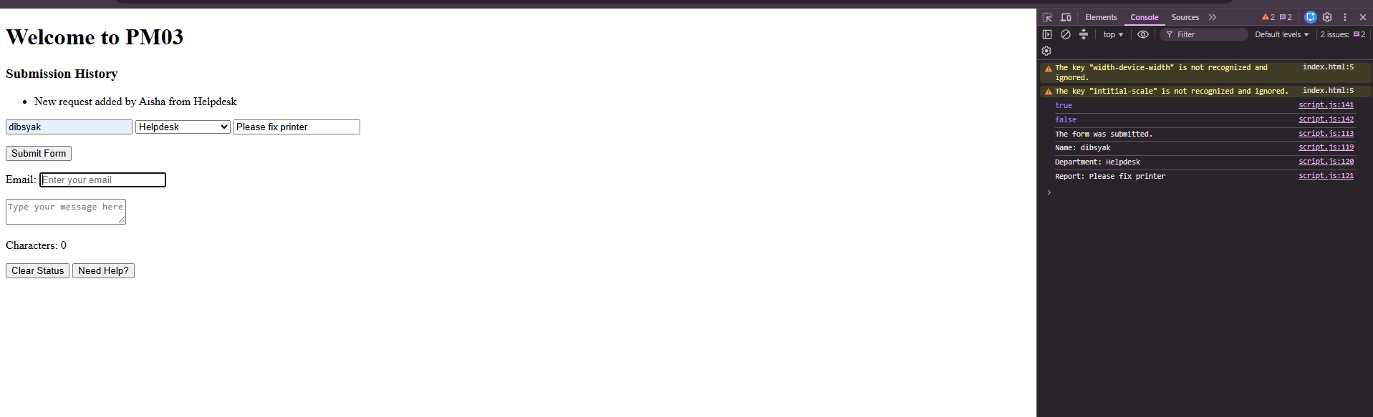
After:
